**A**

**Project Report**

**On**

**"Memes Gallery"**

**Prepared by**

**Naitik Patel**

**20DCS083**

**Harshil Patel**

**20DCS076**

**Under the guidance of**

**Mr. Brijesh Panchal**

Assistant Professor

A Report Submitted to

Charotar University of Science and Technology

for Partial Fulfillment of the Requirements for the

4th Semester Software Group Project-II (CE255)

**Submitted at**



**Computer Science & Engineering**

**DEPSTAR**

**At: Changa, Dist: Anand – 388421**



**CERTIFICATE**

This is to certify that the report entitled “**Memes-Gallery**” is a bonafide work carried out by **Mr. Naitik V. Patel (20DCS083)** under the guidance and supervision of **Assistant Prof. Akash Patel & Naina Parmar** for the subject CE244 (For CSE)-**Software Group Project-II** (CSE) of 4th Semester of Bachelor of Technology in **DEPSTAR** at Faculty of Technology & Engineering – CHARUSAT, Gujarat.

To the best of my knowledge and belief, this work embodies the work of the candidate himself, has duly been completed, and fulfills the requirement of the ordinance relating to the B.Tech. Degree of the University and is up to the standard in respect of the content, presentation, and language for being referred to the examiner.

|  |
| --- |
| Prof. Akash Patel  Information & Technology.  DEPSTAR, Changa, Gujarat.  Prof. Parth Goel Dr. Amit Ganatra  Head of Department – Computer Principal, DEPSTAR  Science & Engineering, DEPSTAR Dean, FTE |
|  |
| **Devang Patel Institute of Advance Technology And Research At Changa, Ta. Petlad, Dist. Anand, PIN: 388 421. Gujarat** |

# **DECLARATION OF ORIGINALITY**

I hereby declare that the project report entitled “Memes-Gallery” submitted by me to Devang Patel Institute of Advance Technology and Research, Changa in partial fulfillment of the requirement for the award of the degree of B.Tech in Computer Science & Engineering, DEPSTAR/FTE is a record of bonafide CE255 Software Group Project-II carried out by me under the guidance of Prof. Akash Patel & Prof. Naina Parmar. I further declare that the work carried out and documented in this project report has not been submitted anywhere else either in part or in full and it is the original work, for the award of any other degree or diploma in this institute or any other institute or university.

Naitik Patel (20DCS083)

Prof Akash Patel

Assistant Professor

DEPSTAR,CHARUSAT-CHANGA

**ACKNOWLEDGEMENT**

We would like to express our special thanks of gratitude to our guides **Prof. Akash Patel** & **Prof. Naina Parmar** who allowed me to do this wonderful project on the topic ‘**Memes-Gallery**’, and made themselves available for all the queries, questions, and suggestions from their busy schedule.

Secondly for the success of my project, I would like to acknowledge the world of the Internet is YouTube, W3 schools and ,websites like which it very easy for me to learn web development.

Thank you,

NAITIK PATEL

(20DCS083)

**ABSTRACT**

As a human everyone needs some entertainment In this busy life. many of us are watching movies and comedy videos. one of the best things is memes by which we can get more entertainment in less time. But the problem is that there is not any particular platform only for memes. There are many platforms like Instagram and Facebook on which users can find memes but there are a lot of things other than memes. So I decided to create a platform like Instagram but only for memes named “Memes-Gallery”. And also tried to add an important component “memes generator” to the idea given by the faculty. And I have created the project which is hosted on Vercel and also on Github. the link to the project is <https://memes-gallery-reactjs.vercel.app/> where users can sign in and use the web app.

**TABLE OF CONTENTS**

Abstract iv

Acknowledgment v

Table of contents vi

List of figures vii

Chapter 1 Project Definition 1

* 1. Project Overview 2
  2. Objective 3
  3. Scope 3
  4. Tools and Technologies 4

Chapter 2 Description 11

* 1. Project Planning 11

2.1.1 Gantt Chart 12

Chapter 3 Major Functionality 13

3.1 Functionalities 13

Chapter 4 System Flow Chart 16

4.1 Flow chart 16

Chapter 5 Screenshots of Project Output 19

Implementation Environment 20

* 1. Coding Standards 21

5.3 Example 22

Chapter 6 Limitations of The Project 25

Chapter 7 Project Outcomes 27

7.1 Summary of project work and outcomes 28

Chapter 8 Future Enhancements 29

Chapter 9 Reference 31

# **LIST OF FIGURES**

4.1 Flow Chart 17

5.1. Login & Signup Page 19

5.2. Home Page 19

5.3. Rent Page 20

5.4. House Detail Page 20

5.5. Profile page 21

5.6. Contact Page 21

5.7. Create Listing Page 22

CHAPTER 1

PROJECT DEFINITION

* 1. **Project Overview:**

A Responsive Web Application on which users can sell, purchase And also give their house for rent and take as well.

* 1. **Objective :**

My objective is to make a platform only for the people who want to sell or purchase the properties. It is user-friendly platform so that everyone can post their house and also refer other houses so that they can purchase.

* 1. **Scope :**

As mentioned above it is user-friendly so that is helpful to the people they can have one-one conversations and create a deal without paying any amount to a third-party broker.

* 1. **Tools and Technologies :**
* HTML-CSS

HTML is used for structure and CSS is used for styling.

* JavaScript

JavaScript is a logic of every program.

* React JS

ReactJS is a library of JavaScript. React makes it painless to create interactive UIs.

* Firebase

Firebase is a simplest backend it contains many functionalities like Authentication, database, Hosting, etc.

* Bootstrap & Material UI

It is a CSS Library used to build beautiful UI.

* ES Lint

ES Lint is used to finding an error and fix it in the Code editor.

* Prettier

It is used for the formatting of code.

* Git/GitHub

GitHub is an open-source on which everyone can post their development skills.

* Framer-Motion

It is used to add Animation to Components like cards, images, etc.

* Vercel

Vercel is used for hosting the website.

CHAPTER 2

DESCRIPTION

**Project Planning :**

My objective is to make a platform only for the people who loved memes and share with others. It is like different social media type.

* + 1. **Gantt Chart :**

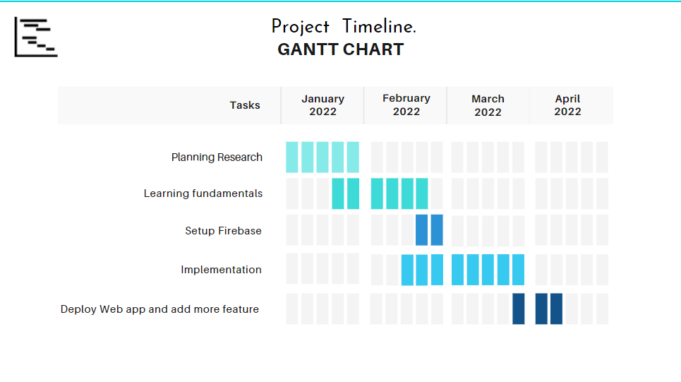  
Fig 3.2 Gantt chart

CHAPTER 3

SOFTWARE AND HARDWARE REQUIREMENTS

* **Software Requirements**
* Browser for Ex. Chrome, Brave, Fire Fox, etc.
* **Hardware Requirements**
* Laptop, Computer, Phone
* 2 GB RAM

CHAPTER 4

MAJOR FUNCTIONALITY

* 1. **Functionalities:**

A Responsive Web Application on which users can sell, purchase And also give their house for rent and take as well.

* User can put max 10 images.
* Attractive UI with animation.
* Contact Landlord section.
* Post house for Rent and Sell.
* Authentication with Google Or Email Password.
* User’s Profile section.
* User can update and delete their house after completed their.
* Different section for special offer on sell and rent houses.
* User can recover Forgot password.

CHAPTER 5

FLOW CHART

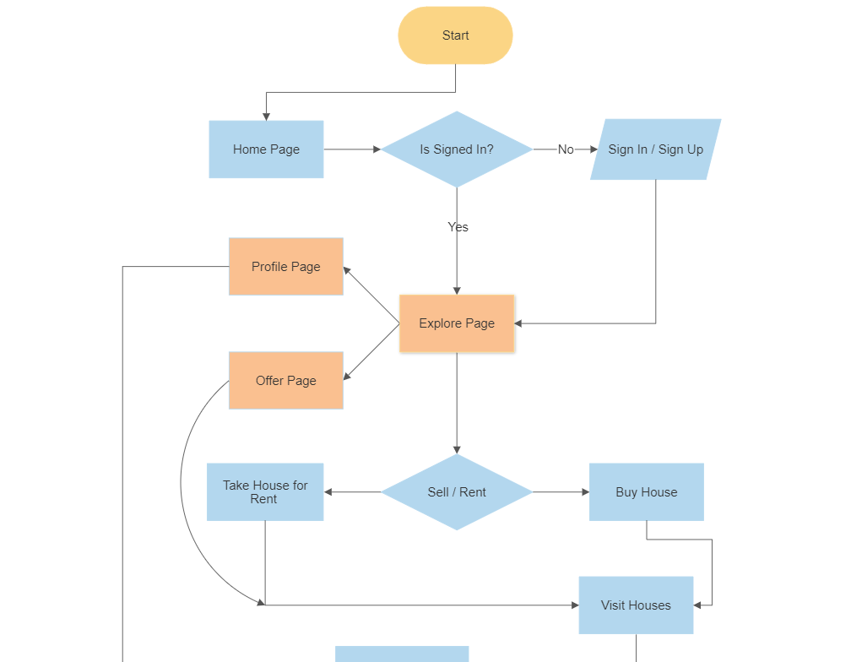

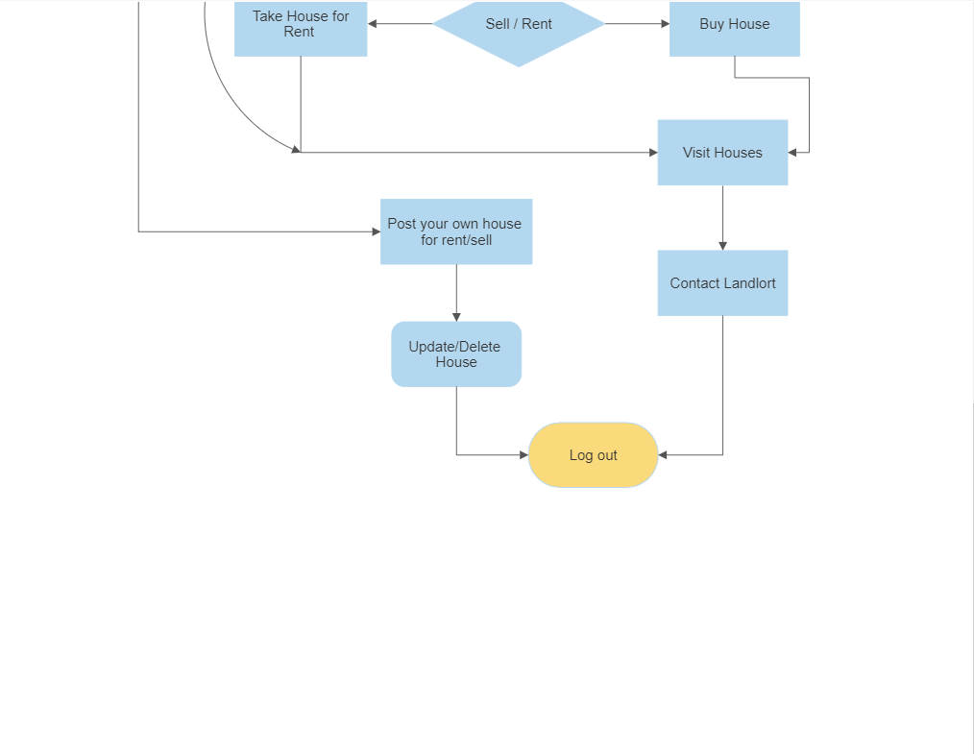

Fig 4.3 Flow chart

CHAPTER 6

SCREENSHOT OF PROJECT

This is the fist page of my project. User will signin before move to the main page or user can Signup first and then move further.

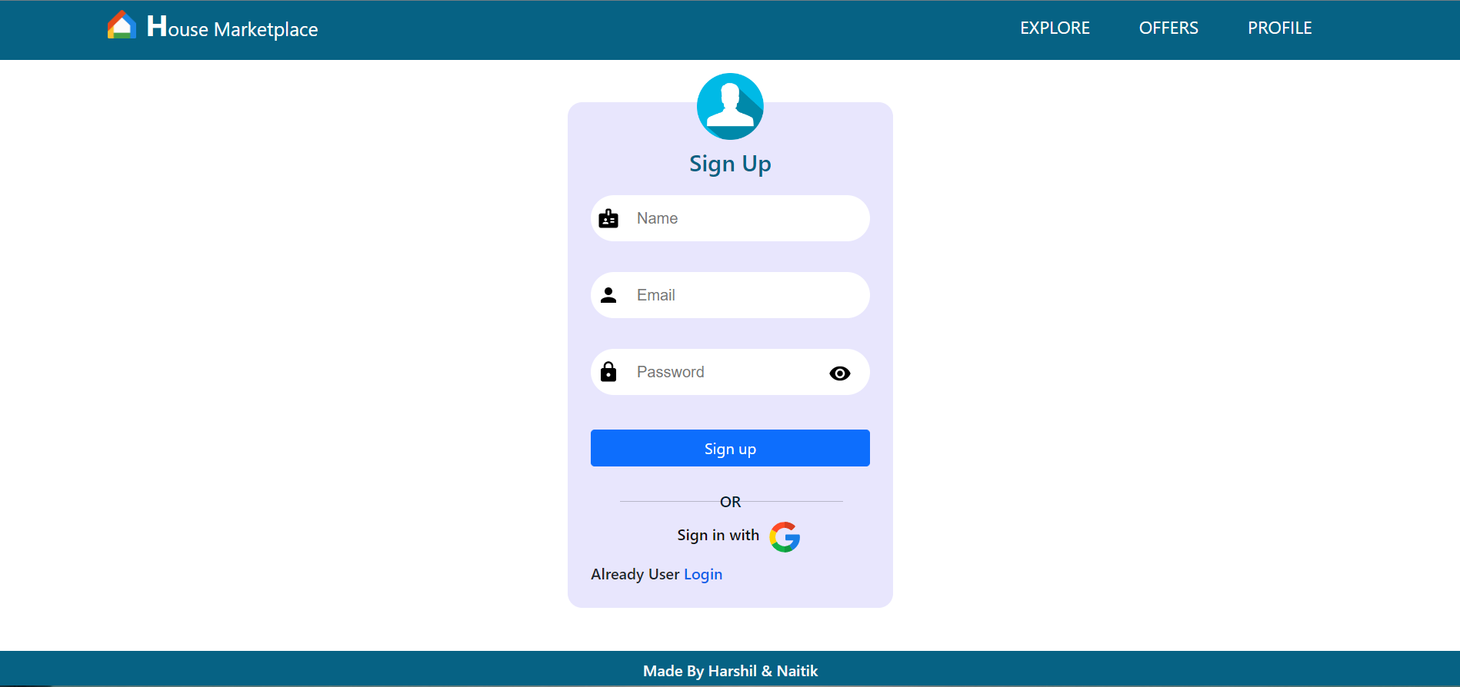

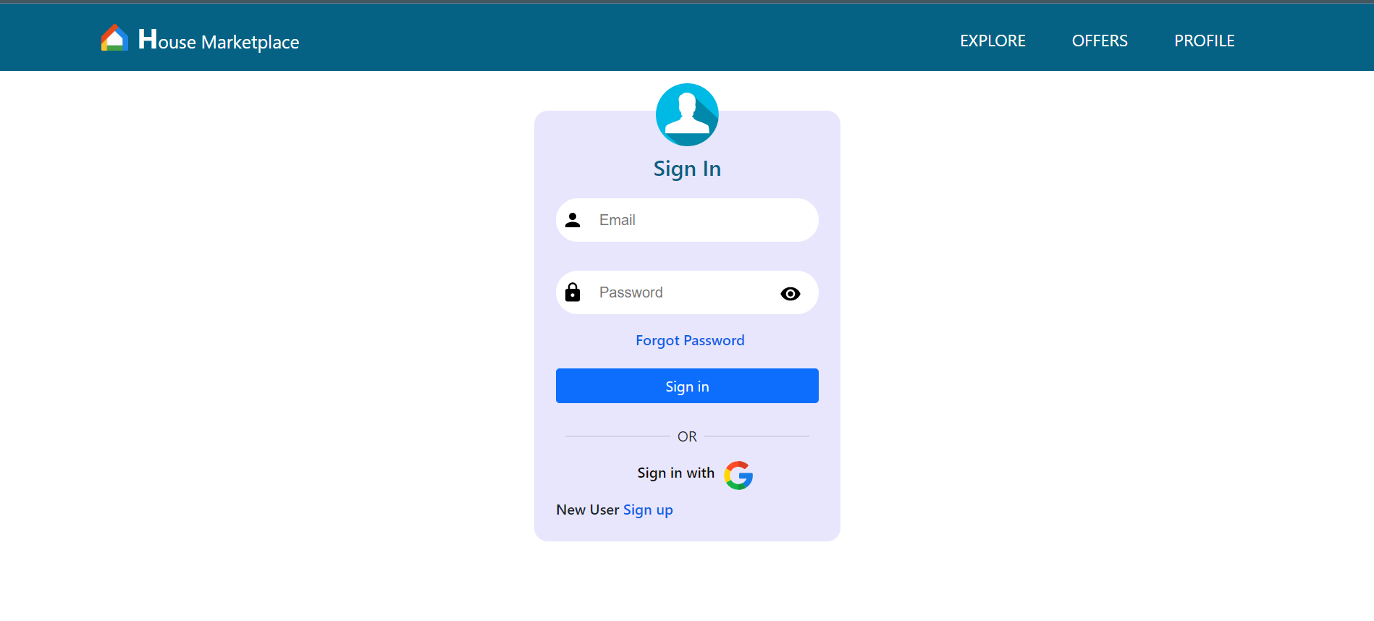

Fig 5.1 Login & Signup Page

This is the Home page here first you can see the slider which shows newest posted 5 houses for sell or rent by clicking on them you can visit see more details. Also in category user can select by their requirenment.

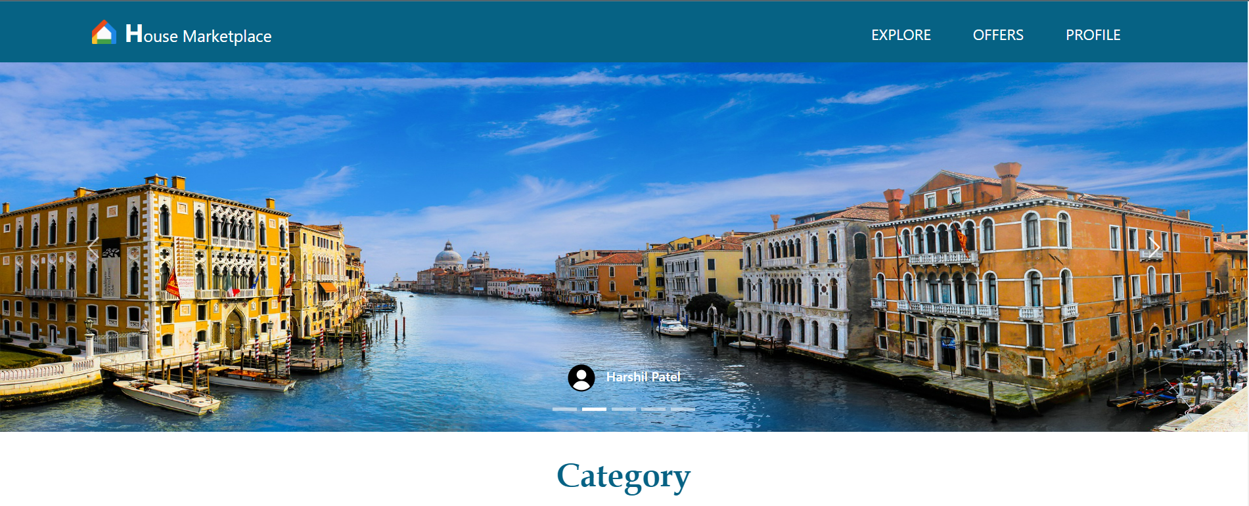 

Fig 5.2 Home Page

Here user can see the houses for rent, by clicking on load more button more houses will be load from database.

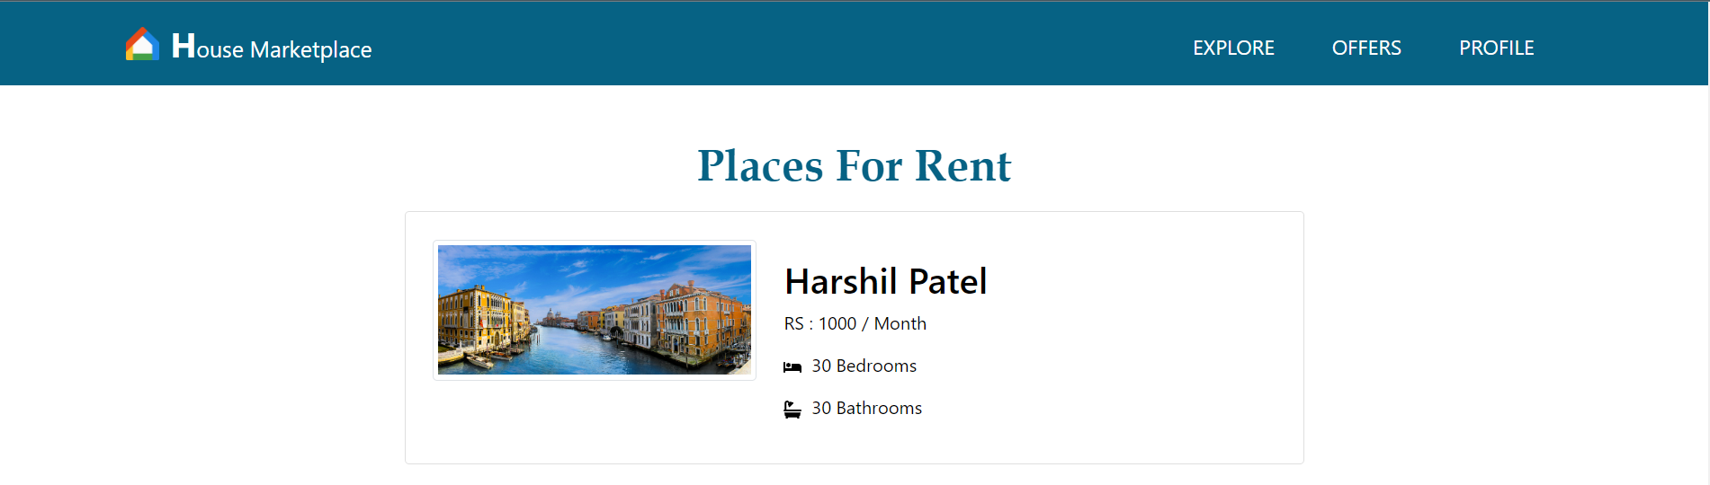

Fig 5.3 Rent Page

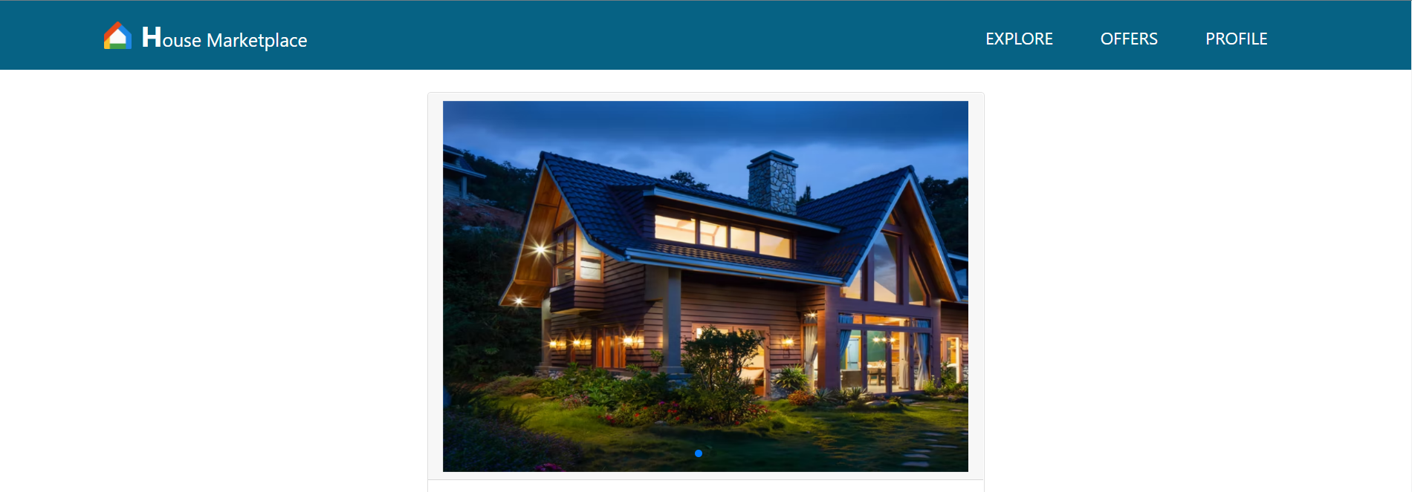

Fig 5.4 House Detail Page

Here User can see Profile Details and Houses that listed by user.

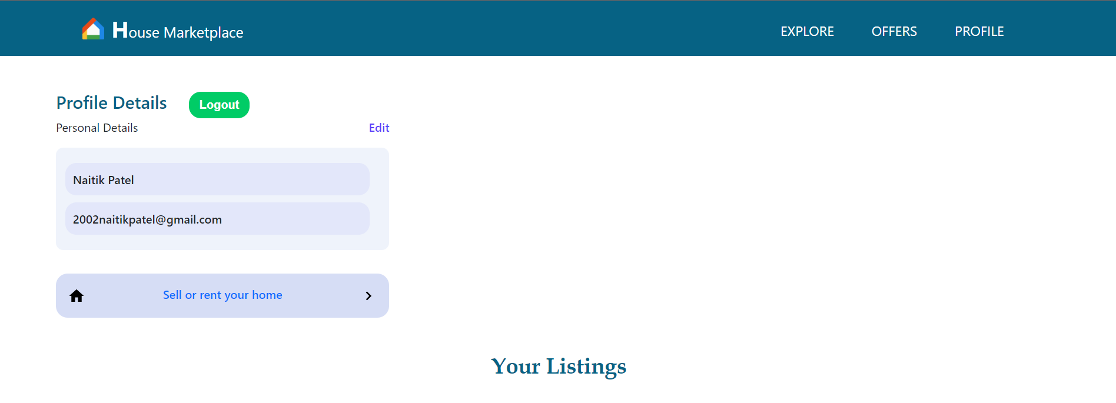

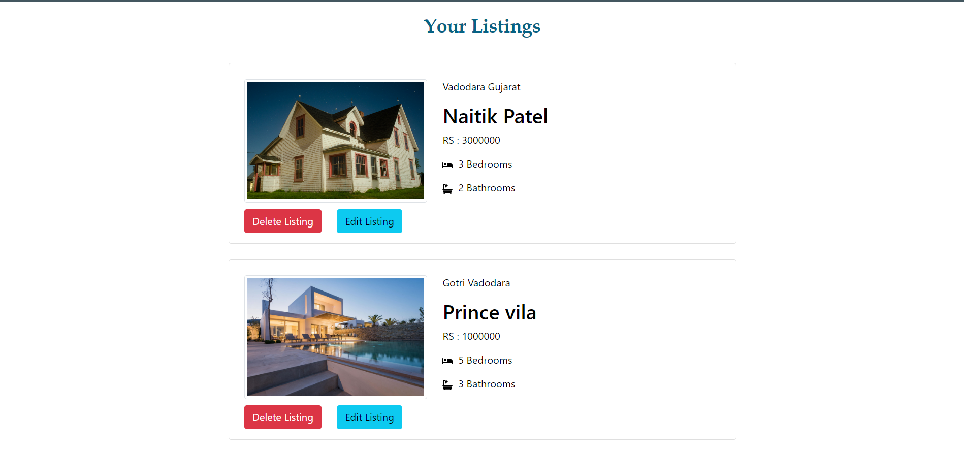

Fig 5.5 Profile Page

Interested can contact to the Landlord via sending message here.

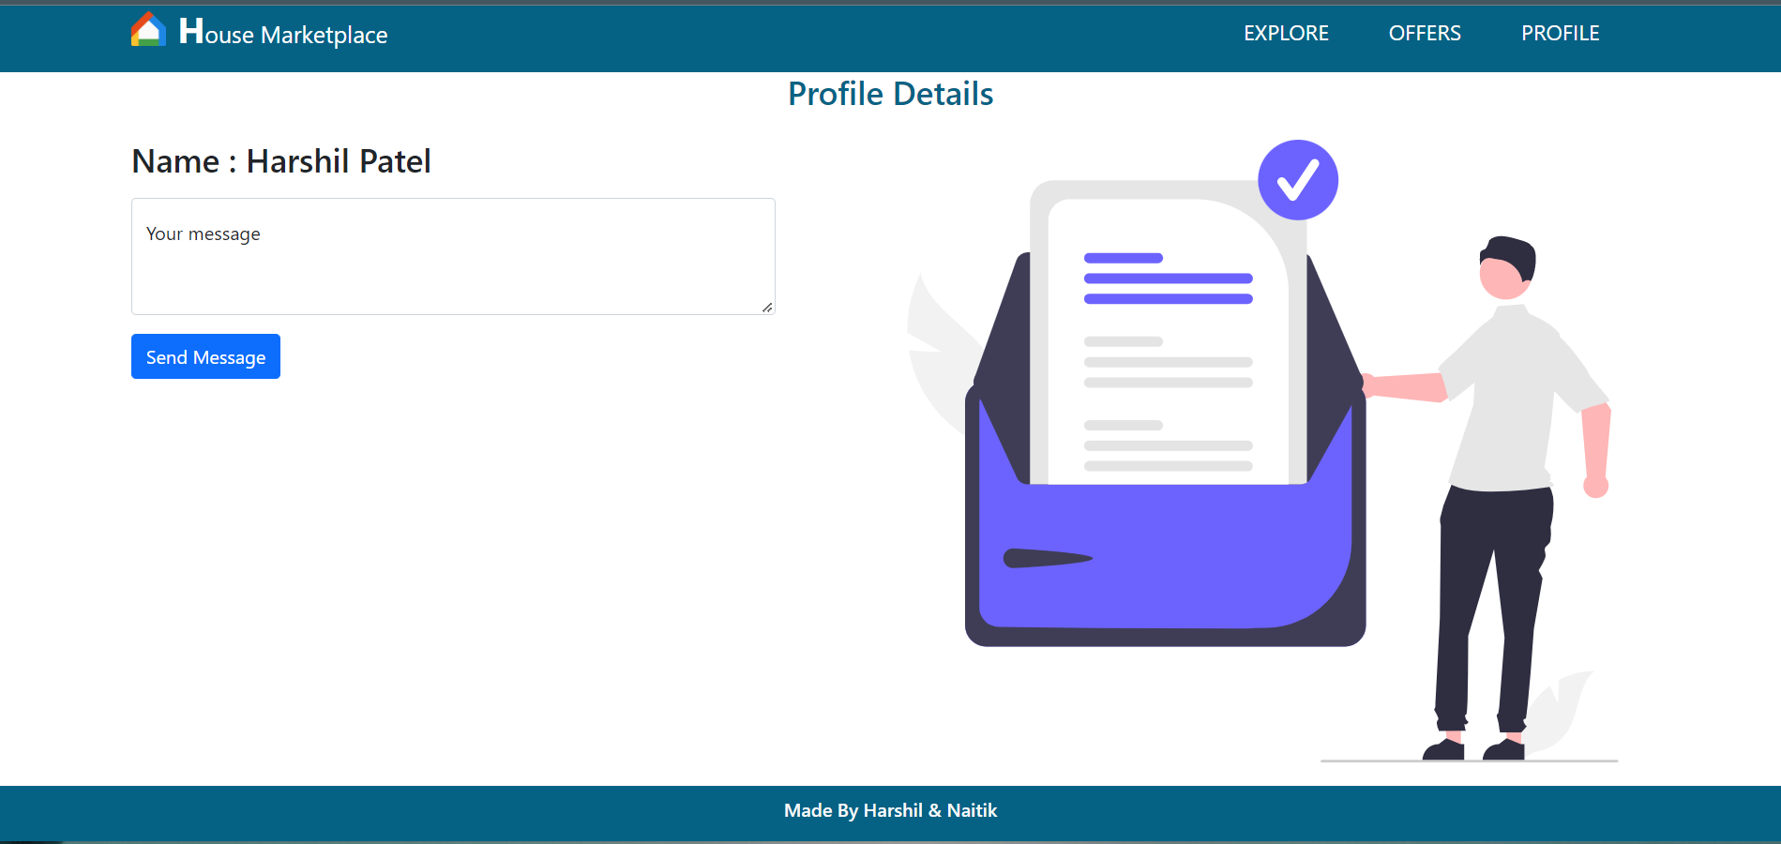

Fig 5.6 Contact Page

User can create listing here. User can select upto 6 images to post. Also they can update this details.

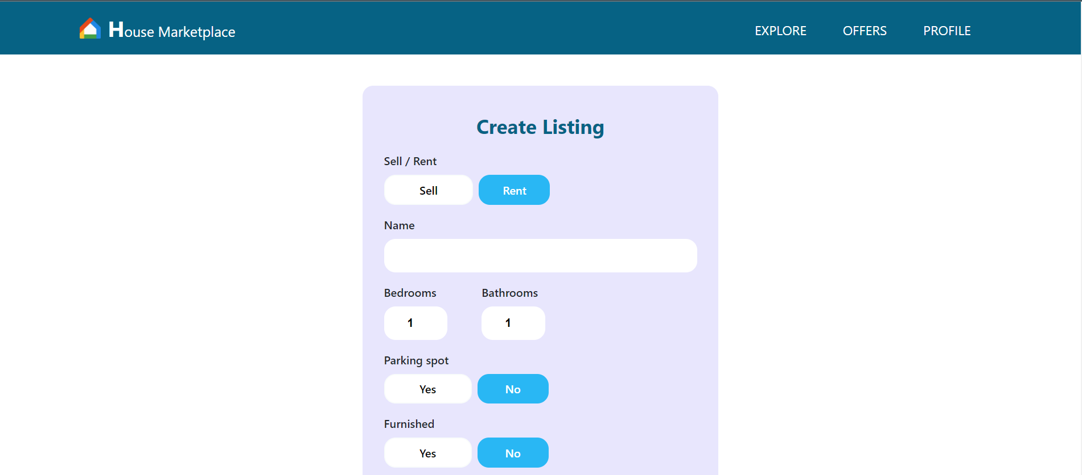

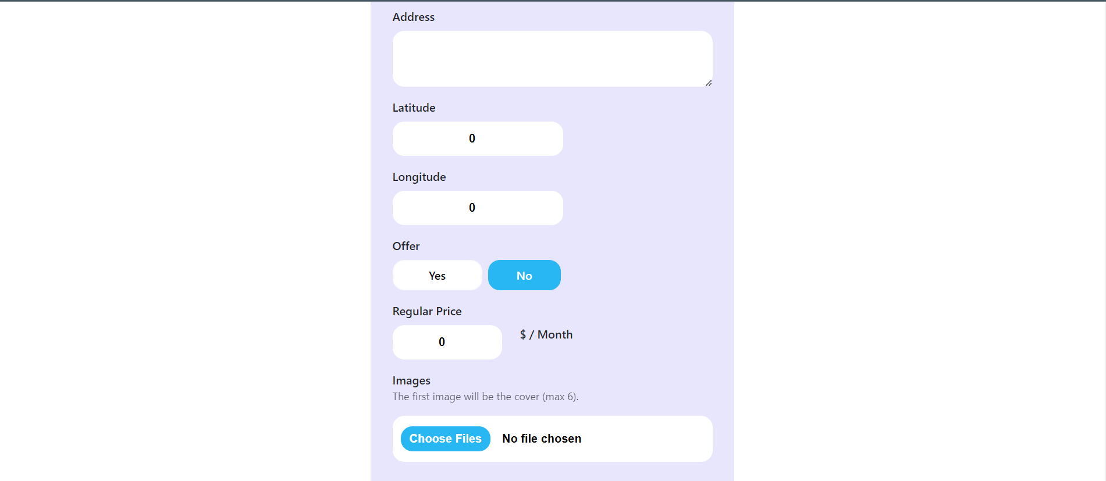



Fig 5.7 Create Listing Page

CHAPTER 7

LIMITATIONS OF PROJECT

**Limitations/ Improvements we could make:**

* Some high quality images may not upload.
* In Offer page sell and rent both type of houses are mixed.
* User can not sort houses by their area.

CHAPTER 8

PROJECT OUTCOMES

**Project Outcomes:**

I introduced to the world of web development, I stared with fundamentals like HTML, CSS and JavaScript. Then I build up to ReactJs and it’s libraries. Also I learned firebase database and authentication and created my first full stack website. I learned GitHub and posted my project on it. Also I used API in my project so I got knowledge how to fetch data from an API. At the end I have hosted my website on Vercel.

CHAPTER 9

FUTURE ENHANCEMENTS

**Future Enhancements:**

* I will try to add Videos as well as GIFs.
* Login with other methods like Facebook and email id pass.
* Try to filter memes by categories.
* And many more upgrades that we can think of or as suggested by anyone.

CHAPTER 10

REFERENCES

**References:**

* <https://vercel.com/>
* <https://docs.github.com/en/get-started/using-git/about-git>
* <https://prettier.io/docs/en/index.html>
* <https://eslint.org/docs/user-guide/getting-started>
* <https://reactjs.org/tutorial/tutorial.html>
* <https://www.learn-js.org/>
* <https://www.w3schools.com/html/>
* <https://www.cs.utexas.edu/~learnlogic/truthtables/>
* <https://web.stanford.edu/class/cs103/tools/truth-table-tool/>